Carcastrophe présentation itch io

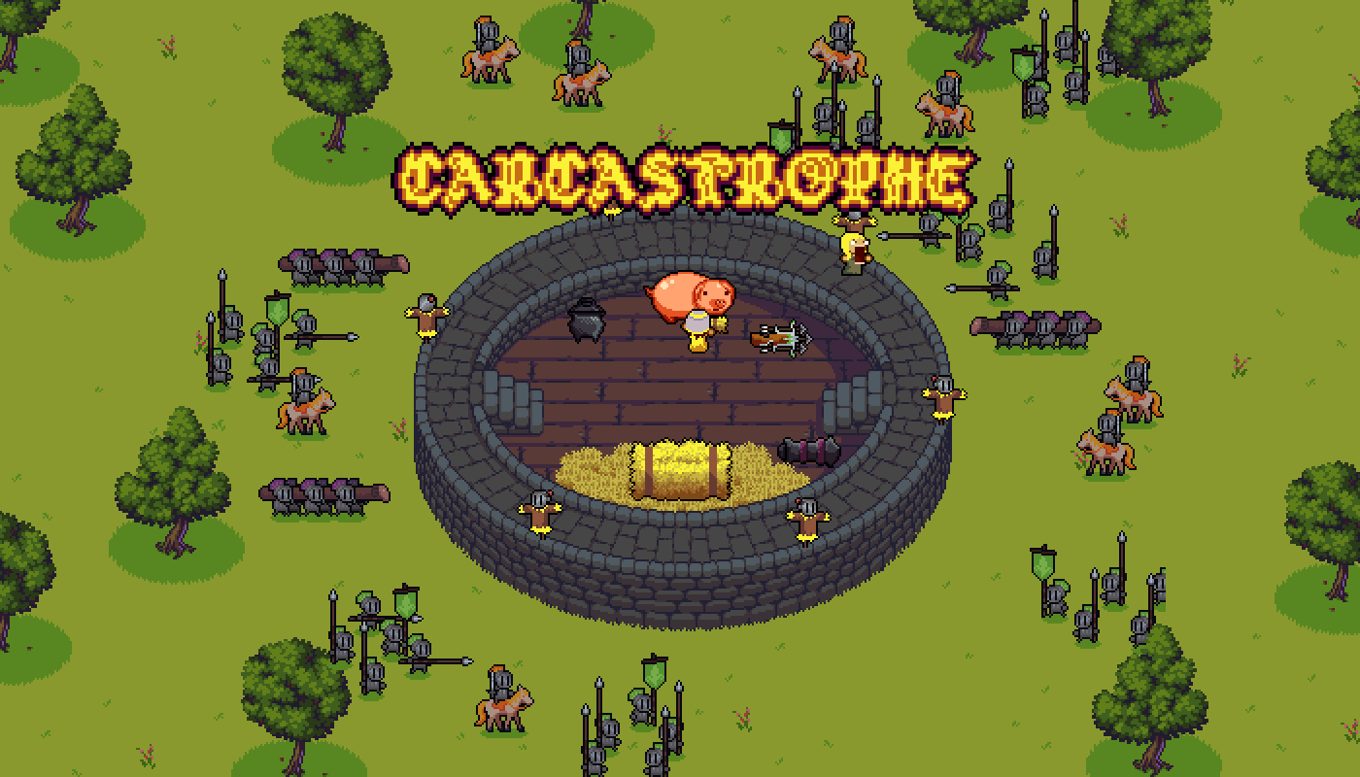

**Story**

The city is besieged by the mighty army of Charlemagne. King Ballak is dead and his bride, Dame Carcas has to defend the falling castle and her dying people by any means necessary… Including trickery!

Embody Dame Carcas and her faithful friend, dame Sonne, and create the legend of Carcassonne, the city that failed an emperor!

**Winning conditions**

The situation is critical but the attacker doesn’t know what’s going on in your castle, Let him believe you have countless soldiers by your side and enough food to feed them for months!

Maintain the bluff by firing from behind straw puppets and don’t forget to feed the pig ! It is the key to your victory!

**Defense**

If enemies can reach your castle, your trick might be uncovered, scare them by firing towards them

Choose your weapon wisely.

The crossbow

C:\Users\jeanw\AppData\Local\Microsoft\Windows\INetCache\Content.Word\Arbaliste.png

The Cassoulet launcher

Lance cassoulet

The Cannon

Canon

Controls

Playable with 2 controllers.

2 players on one keyboard

One player with a controller and the other on keyboard.

About the game.

This game was made during the Game Pratic’ 2019, a game jam in Montpellier, France. It lasted 48 hours and Carcastrophe was awarded the jury’s prize!

The version available here is slightly improved compared to the jam version. We mostly improved usability, input management and feedbacks.

Ces images sur le côté:

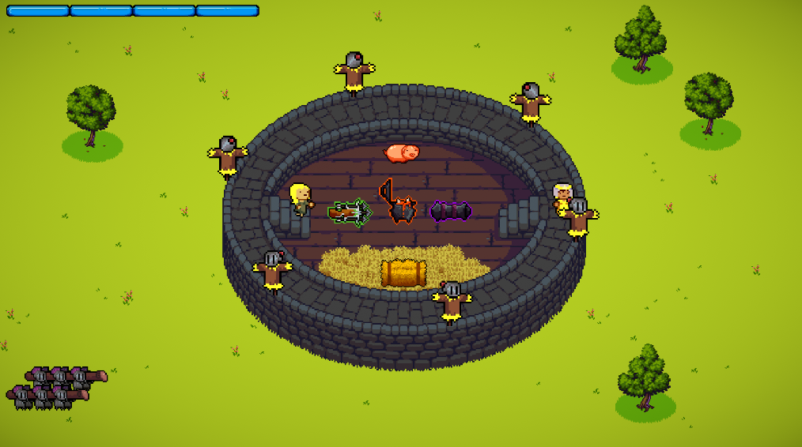

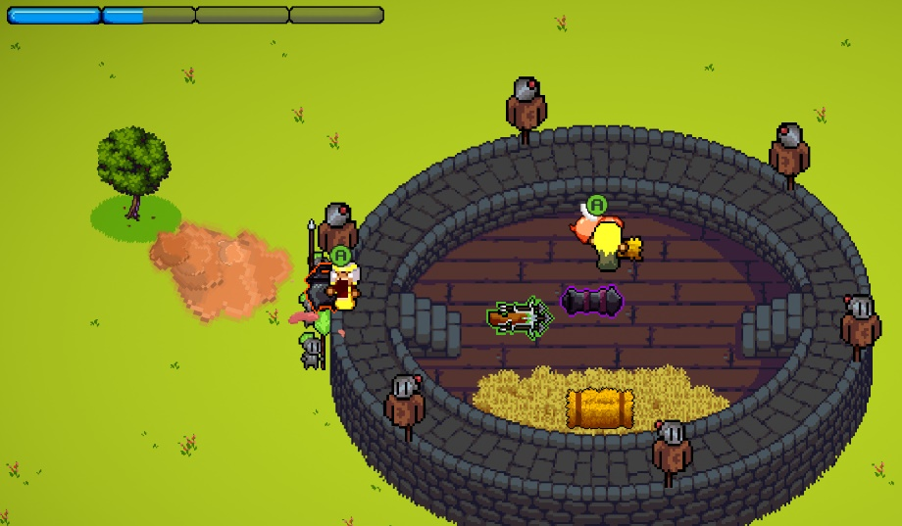

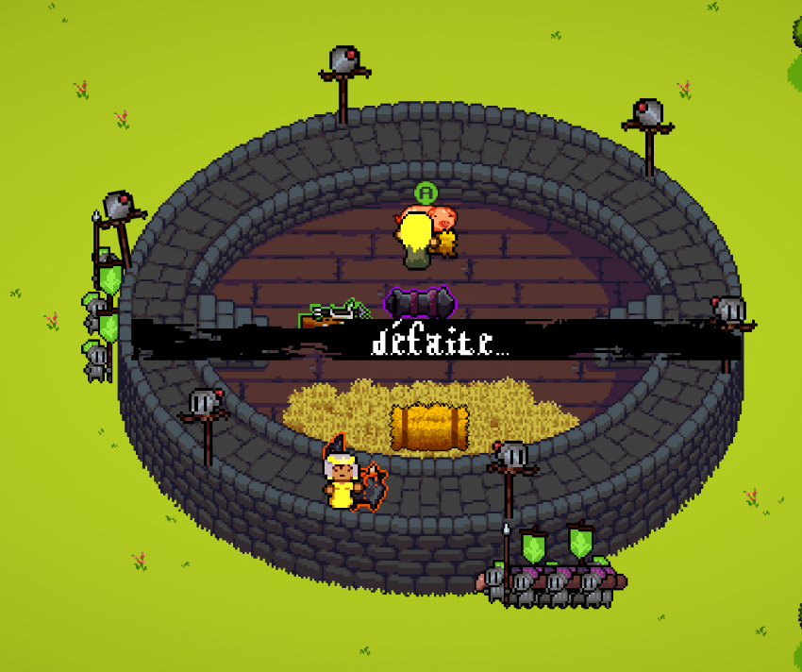

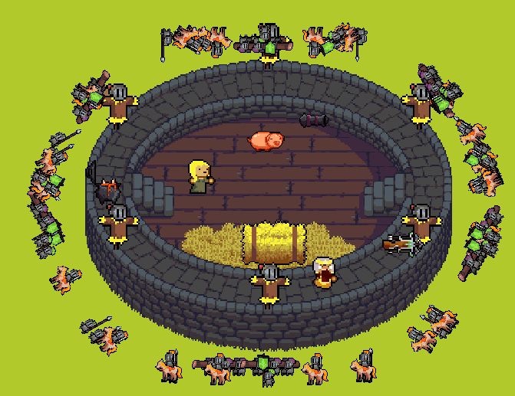(celle-ci, à discuter :p)